Experiment 1：Let Arduino say World Hello
1、Hello World！
First to practice a no need other auxiliary components, just a simple experiment Arduino and a download line, so that our Arduino say "World Hello!", which is a Arduino and PC communication experiments, this is an entry test, hoping to lead you into the world of Arduino.
2、Electronic components used in the experiment, and electronic module：
1.Arduino board 1 PCS
2.USB Data line
Arduino controller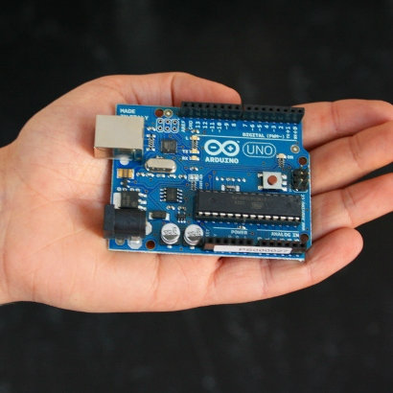
USB Download line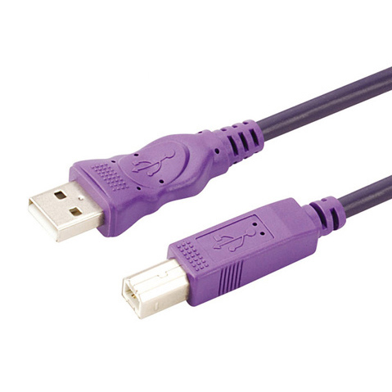
accordance with the above mentioned will be Arduino driver installed, we open the Arduino software, write a program for Arduino to receive our instructions on the display "World Hello!" string, of course, you can also let Arduino do not have to accept any instructions directly to the "World Hello!", in fact, very simple, a If () statement can let your Arduino to listen to your instructions, we have to use the digital Arduino comes with 13 LED, so Arduino to receive instructions when the LED flashes, and then show "World Hello!"
3.Here to give you a section of the reference program.
//////////////////////////////////////////////////////////
Int Val; / / define variables val
int ledpin=13;//Define digital interface 13
void setup()
{
Serial.begin(9600);//Set to 9600 baud, here to with software set consistent. When access to a particular device (such as: Bluetooth), we also want to with the baud rate of the other device to reach consensus.

PinMode (ledpin, the output); / / set the number 13 is the output port, Arduino we use I / O port to similar such a definition
}
void loop()
{
val=Serial.read();//Read the PC machine sent to the Arduino of the command or character, and the command or character assigned to the val
if(val=='R')//Determines whether the received instruction or character is "R"
{ / / if the received character is "R"
digitalWrite(ledpin,HIGH);//Lighting the number 13 LED.
delay(500);
digitalWrite(ledpin,LOW);//Out of 13 LED / / digital
delay(500);
Serial.println("Hello World!");//Display "World Hello!"
}
}
////////////////////////////////////////////////////////////////
Experimental results, screenshots.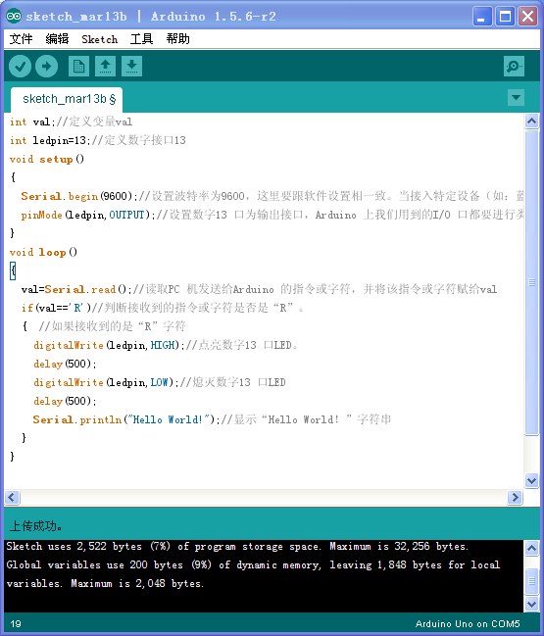
Click Serial port monitor 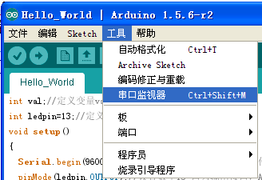
input R
LED will flash；
Will receive information from hello world arduino
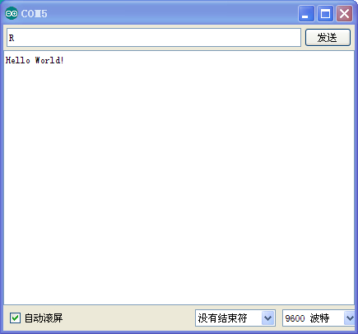
End of experiment
Note:COM port to choose the right,or not receive data,the following figure is the COM port selection
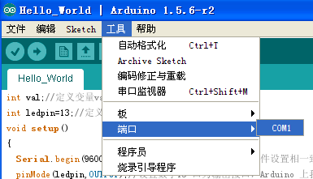
端口选择正确后，实验很容易就OK啦。
Port selection is correct, the experiment is easy to ok it.

